Fitchburg State University

CSC 7014 Practice Computer Programming

Instructor: Nguyen Thai

Due: 9/30/2016 at 5:00 PM

Student:

**CSC 7014 Assignment 3: Chinese Zodiac**

The purpose of this assignment is to learn how to program the if-elif-else statements and also enhance your graphics programming skills. Your program is to be written in the Python language. You are required to use Turtle graphics as user output presentation. You will be graded for output correctness, code comments, code indentation, descriptive variables and source code file header completeness.

As you work through the assignment be sure to answer all questions (type your answers into this document) and take all screenshots as requested (copy them into the document). For the screenshots, you can use the Snipping Tool that is built-in to Windows to capture the important parts of the lab as highlighted in the document below. Do not delete the contents of this file. When finished, you will submit the document source code file and associated data files to the instructor via Blackboard. DO NOT SUBMIT ZIP FILES OR INDIVIDUAL IMAGES. If you have any questions or need any clarification, email the instructor *before* the deadline.

1. In this lab you are to write a program in Python called *chineseZodiac.py* to calculate the Chinese Zodiac for a given user input as a year number.
2. You are to create a Chinese Zodiac with 12 animal names on a circle as shown below. You are required to use Turtle graphics to create the Chinese Zodiac circle. The radius of the circle is 200 units long. The zodiac circle is to be drawn with black color.

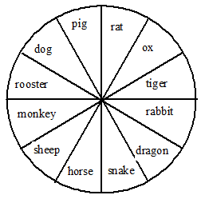

1. The Chinese Zodiac is based on a 12-year cycle, and each year in the cycle is represented by an animal in following order:
2. Monkey
3. Rooster
4. Dog
5. Pig
6. Rat
7. Ox
8. Tiger
9. Rabbit
10. Dragon
11. Snake
12. Horse
13. Sheep

The value of (year % 12) determines the zodiac sign. For example, 1900 is the year of the rat, since (1900 % 12) is 4.

1. Prompt the user to enter a year number as an integer. You need to check for valid input. For example, negative number is invalid.
2. Calculate the zodiac sign and label the animal name that corresponds to the user’s input in red on the zodiac circle. Label the other eleven animal names in blue.
3. Label your diagram with the title “Year to Chinese Zodiac Conversion”.
4. Write the user’s input and your calculated output on the diagram as:

Year 1900 is the rat!

1. Before coding, think how you are going to tackle this problem, and write a short description of the logic of your program.
2. **INSERT YOUR DESCRIPTION HERE.**
3. First we will take year input from the user and it should be positive integer otherwise it will show invalid input. While loop and if statement will check the condition if it is less than zero then print statement should print “Invalid input” otherwise it will return true and again ask for year input from the user.
4. When the user enters the correct positive integer year value the Screen class will get opened. Draw a circle and lines inside circle using turtle graphics methods and for loop. The circle image with pinwheels will display
5. We take the modulus of the input year and compare the value with the animal name using if else statements. E.g. year=1983(1983%12=3) “Pig” matches with the value “3”. Hence, “Pig” is the animal whose value is 3. So, “Pig” will be displayed in “red” color and rest all others animal names will be displayed in blue color.
6. To print the output i.e. Year 1983 is the pig! We need to take “year” as a string to concatenate with the string i.e. Year __ is the pig! We will use str() which converts the integer value to string.
7. **TAKE A SCREENSHOT** of your input and output, and paste them here. Do not paste your source code in this document.

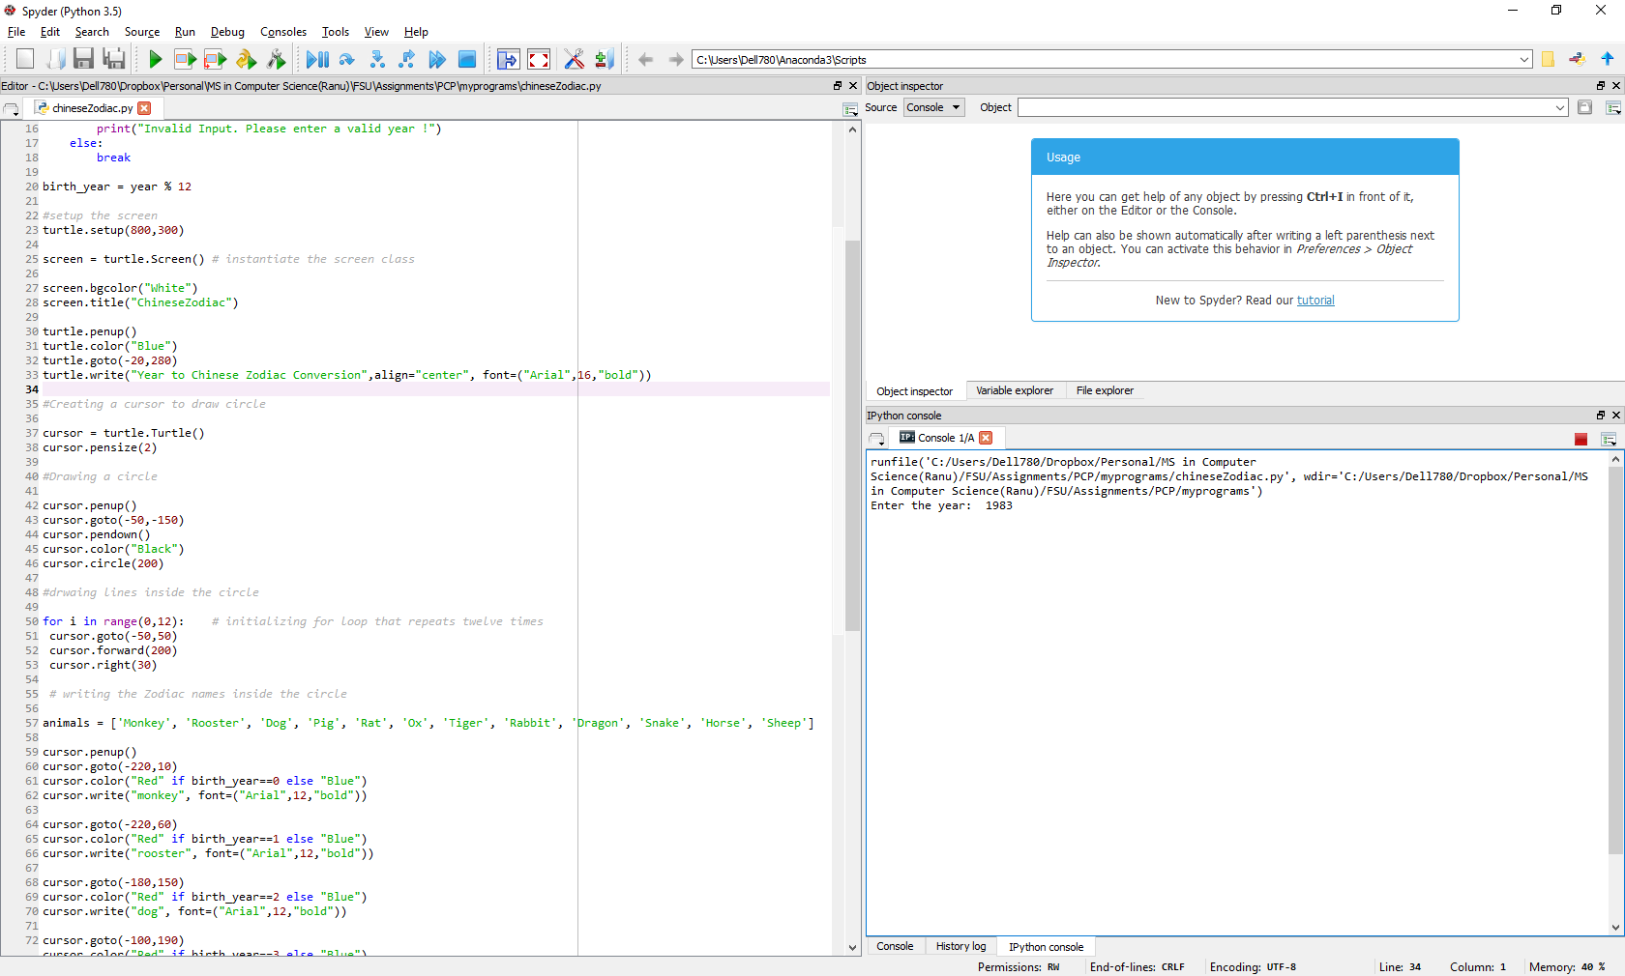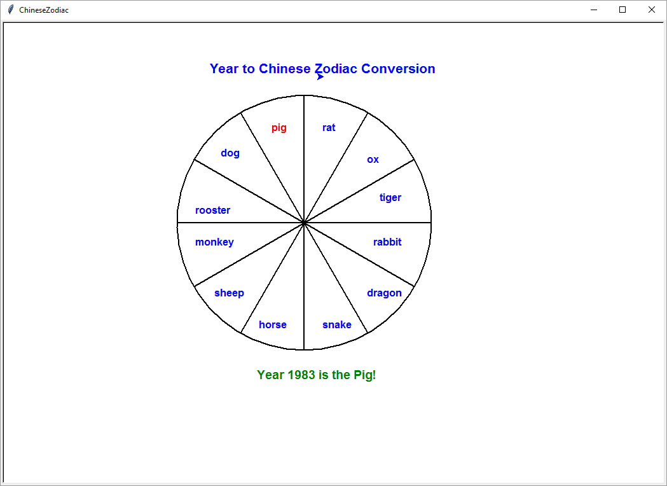

1. Submit your source code (chineseZodiac.py) and this document to Blackboard for grading.